1) Launch one ec2 using Amazon Linux 2 image and add script in user data to install Apache.

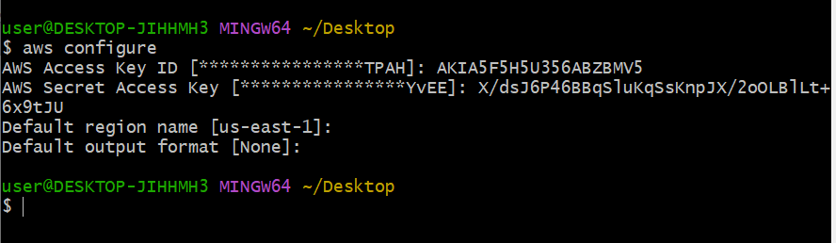

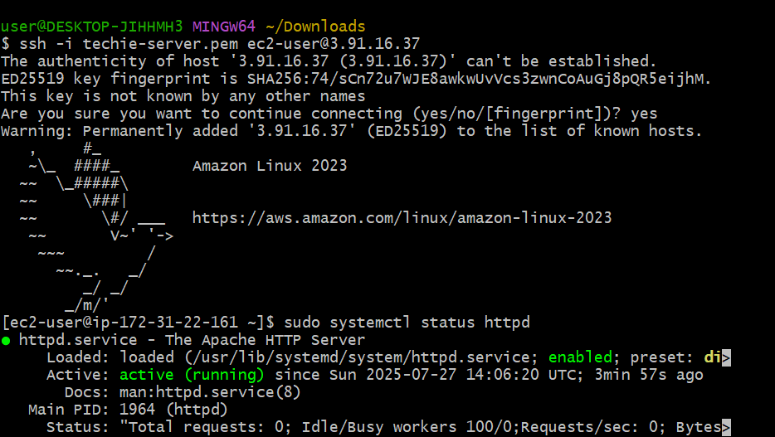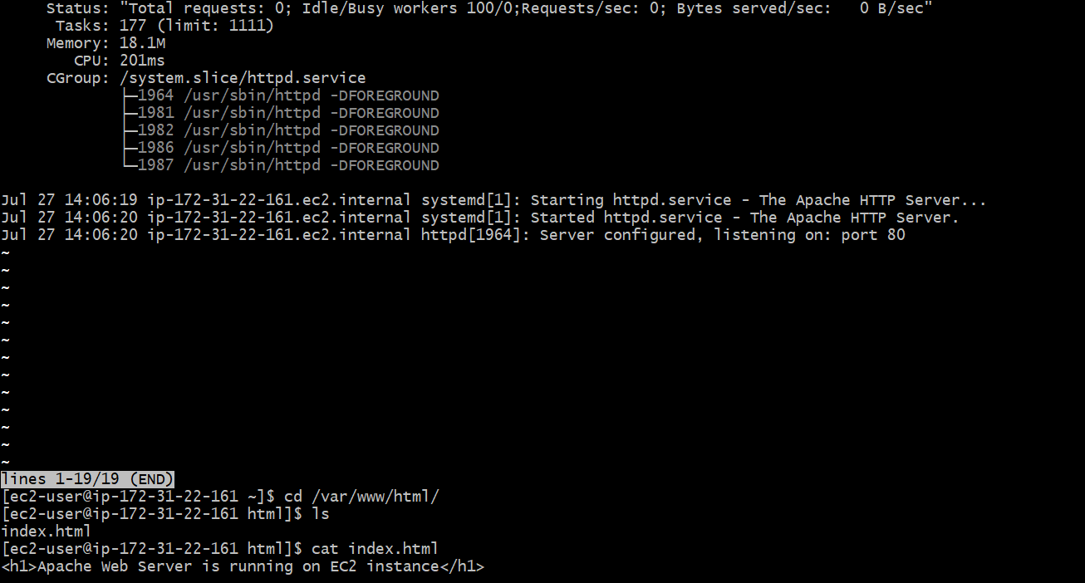

2Q: Launch one ec2 using Ubuntu image and add script in user data to install Nginx.

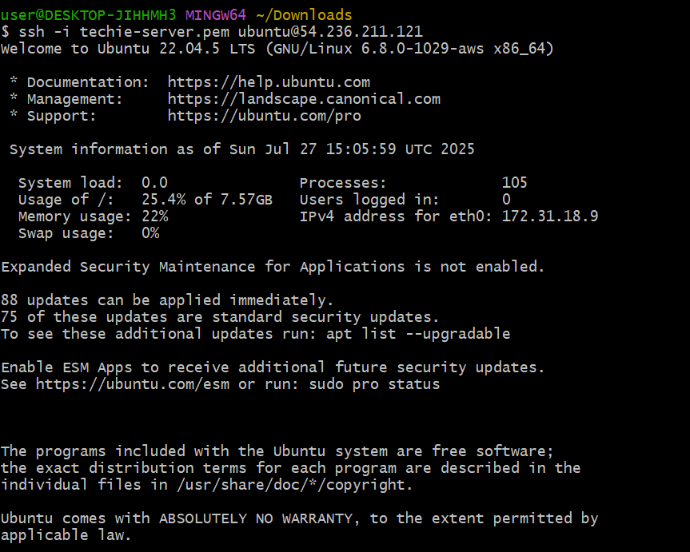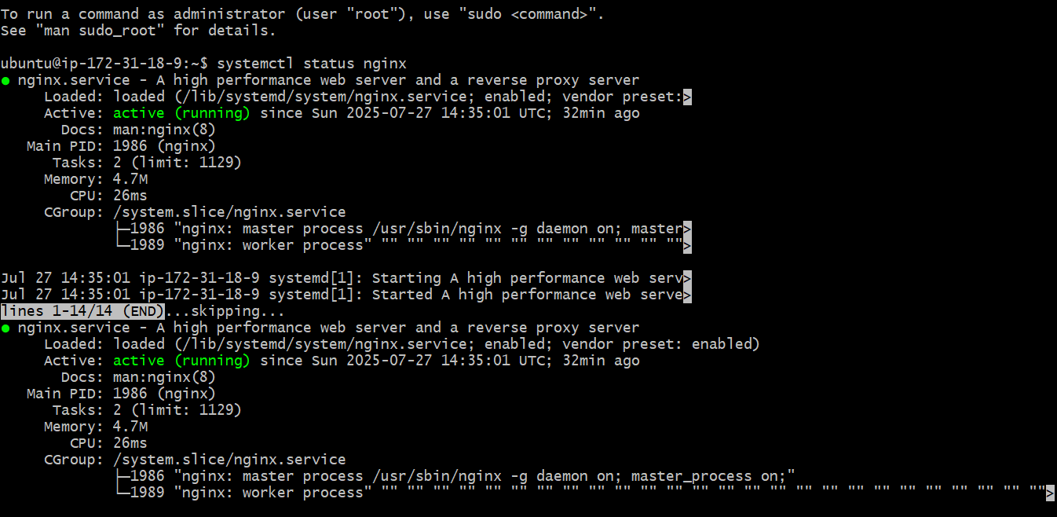

3Q: Launch one windows server and install tomcat in windows.

First create windows server instance by windows server image, t2 medium because windows server need more than 1gb to run.

Second: down load the RDP file

Third : get password in this tab of ec2 only

Fourth: open downloaded file of RDP and give password then it will open the windows server.

Fifth: in a regular(old) windows go to goole and search **download java version** 21 as it’s current version.

And in a same way search for the download tomcat 10 version or any

After downloading just copy paste theses downloads one by one in to the new windows.

And install first java and then install tomcat but becarefull while installing.

<http://localhostname:8080/> in new windows browser.

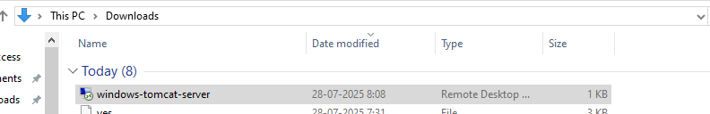

Click on this and connect

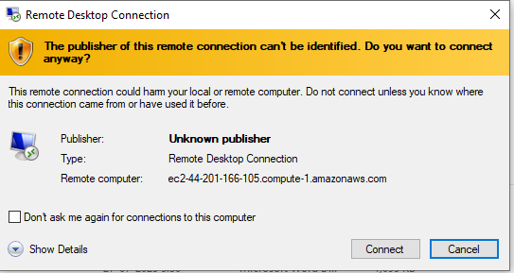

Give password

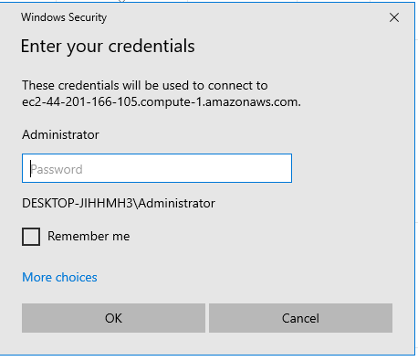

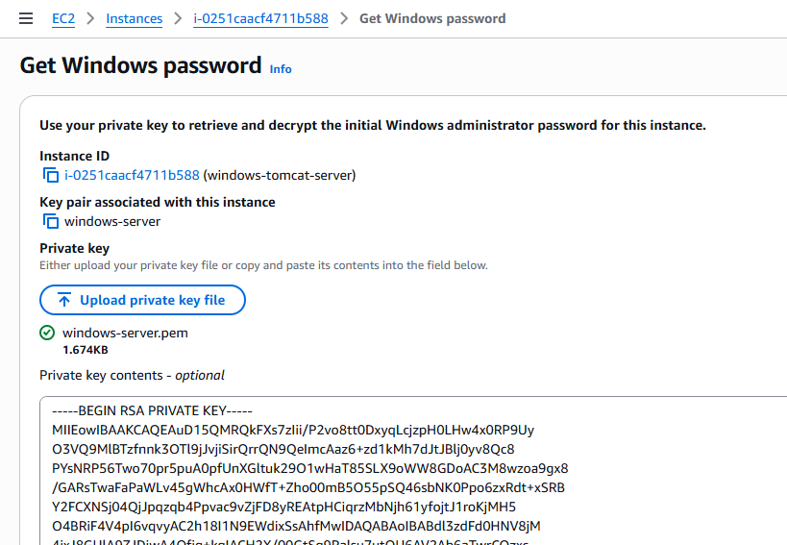

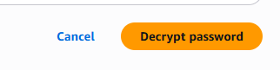click on decrypt password

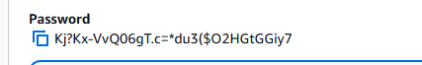 copy password

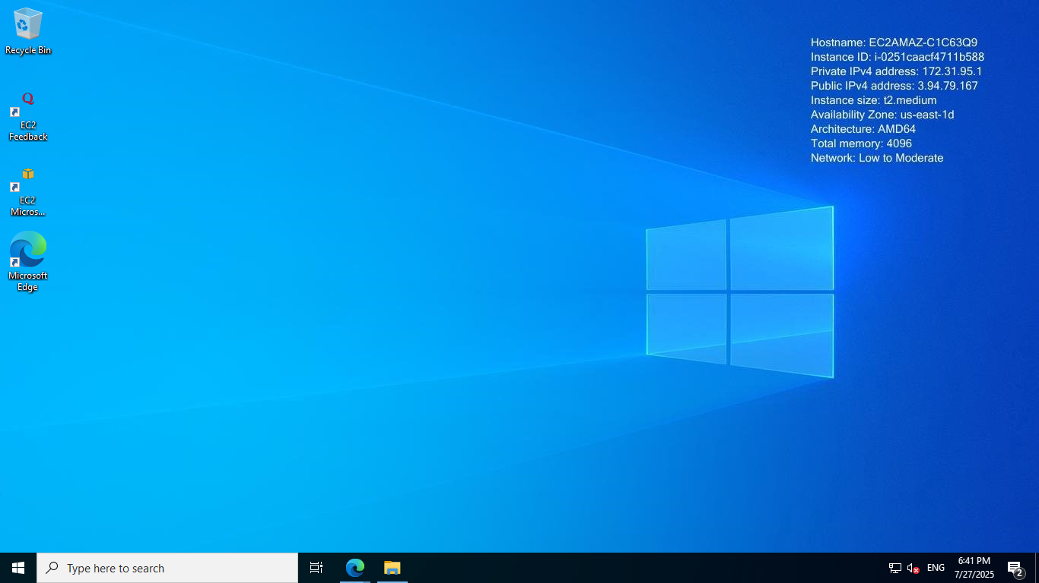

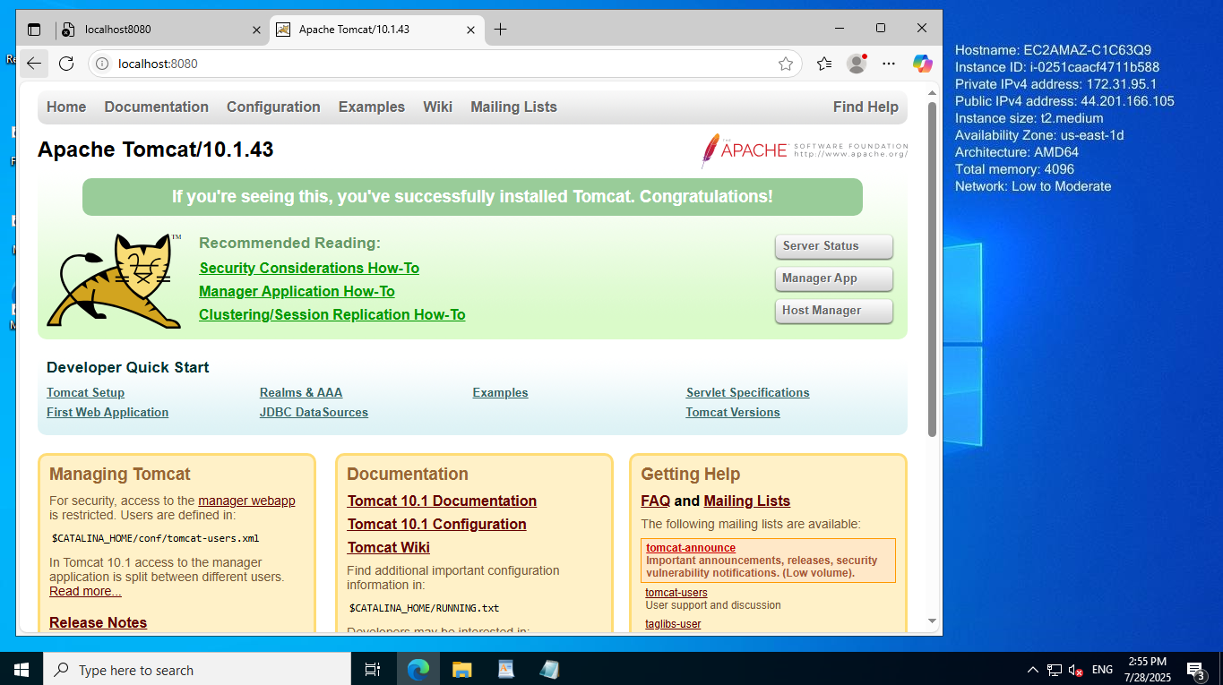

4Q: Take snapshot of the instane created in Task 1.

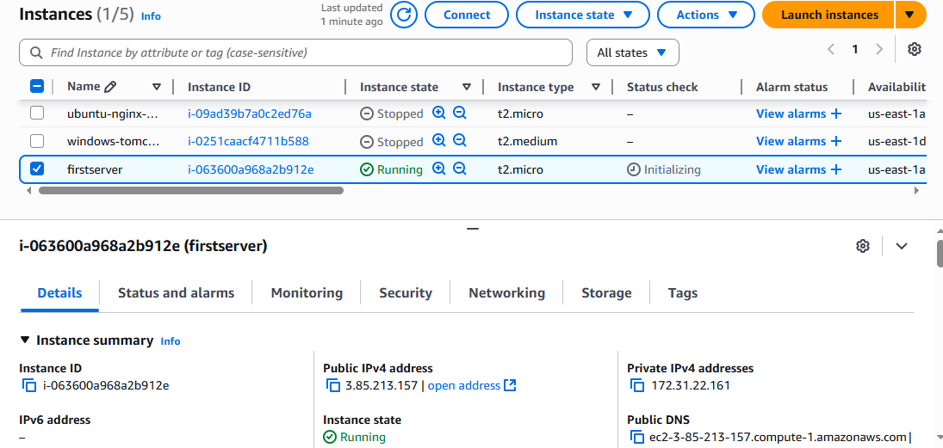

5Q: Assign password less authentication for ec2 created on Task 2.

1. Start your ec2 instance
2. Open gitbash terminal from downloaded pem key area
3. After opening the gitbash give command

ssh-keygen enter

enter

yes

enter

enter

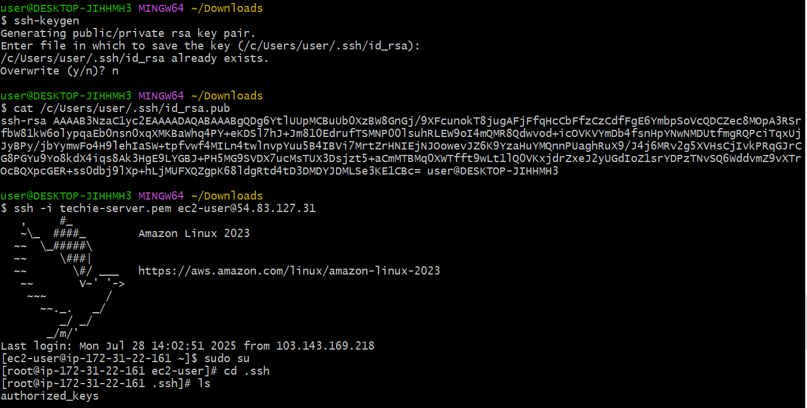

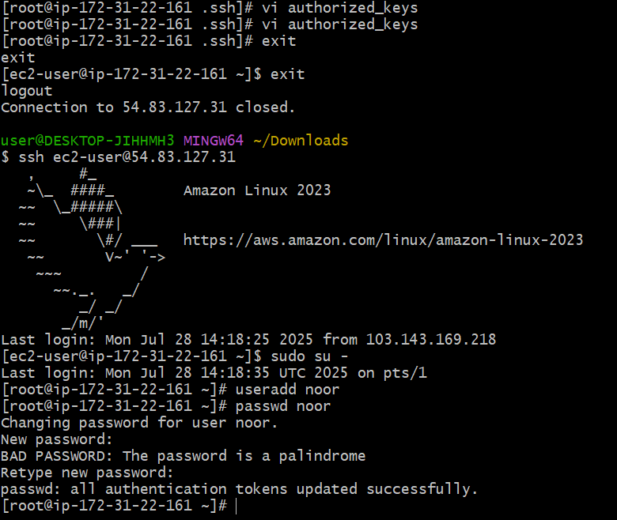

6Q: Launch any ec2 using spot purchasing option.

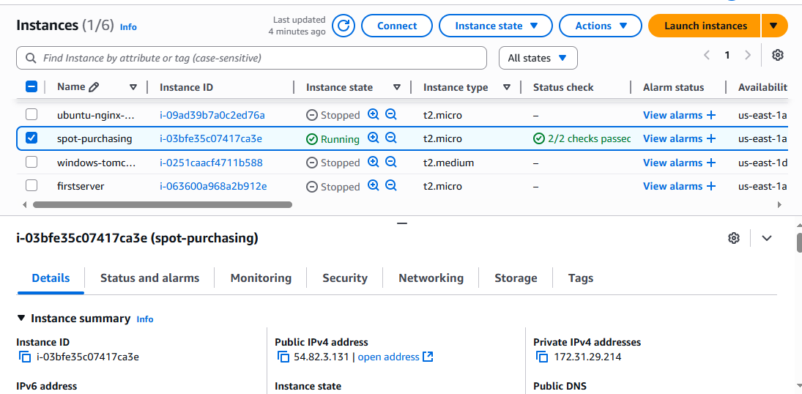

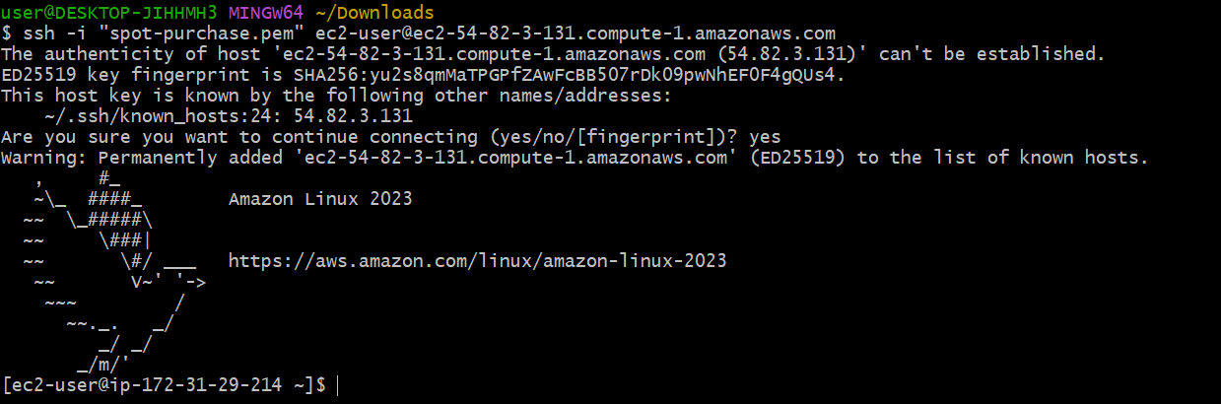

7Q: Enable Termination policy on ec2 created in Task 2.

**Enable Termination Protection via AWS Console**

1. **Go to EC2 Dashboard**:  
   https://console.aws.amazon.com/ec2/
2. **Select Your Instance**:
   * Find the instance you launched in Task 2.
   * Click the checkbox next to it.
3. **Actions > Instance Settings > Change Termination Protection**
4. **Enable** the option:
   * Click **Enable** under *"Enable termination protection"*.
5. **Save** changes.

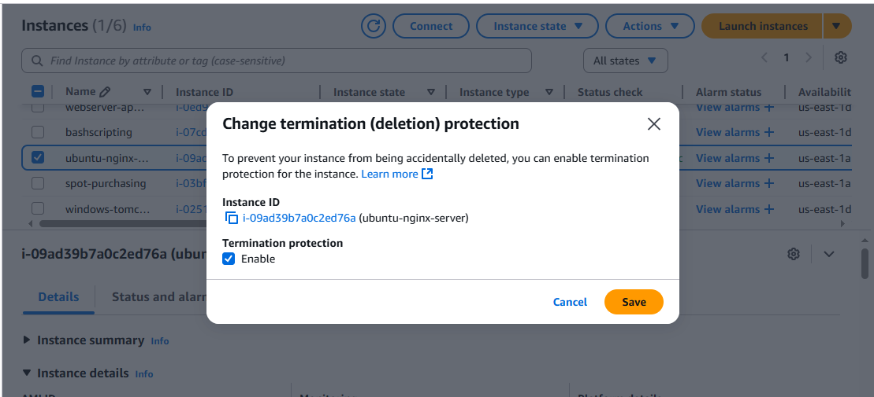

8 Q: Launch one ec2 using Aws CLI.

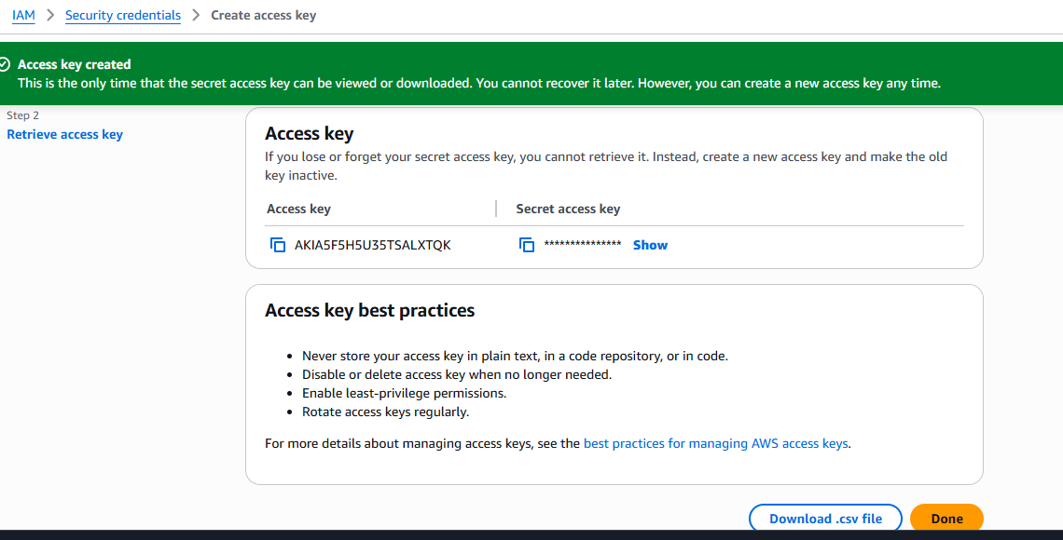

**In searh box give cloudshell**

**Enter the below command and details**

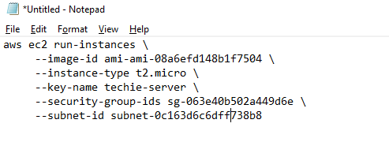

**Copy the above**

**And paste in cloud shell**

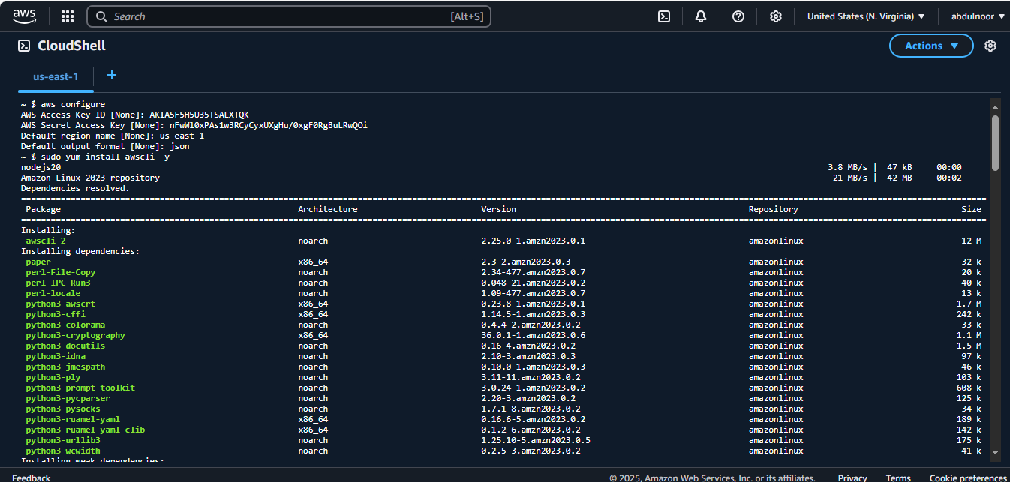

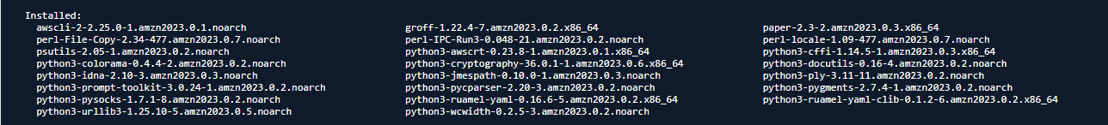

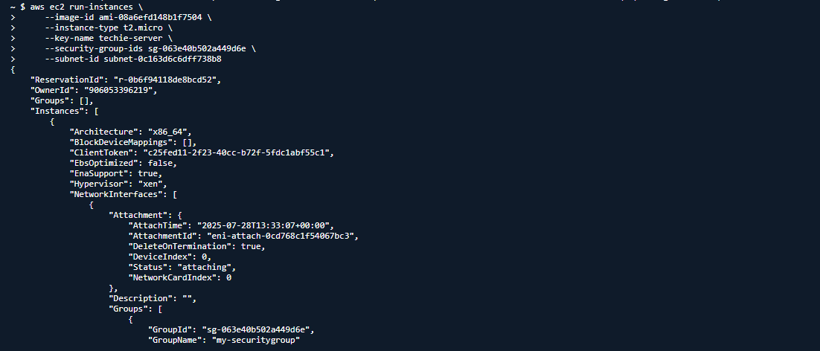

And it creates also EC2 according to cloudshell with a blank name of instance.

